File Search:

Write a command to find all files with the extension .txt in the /home directory and its subdirectories.

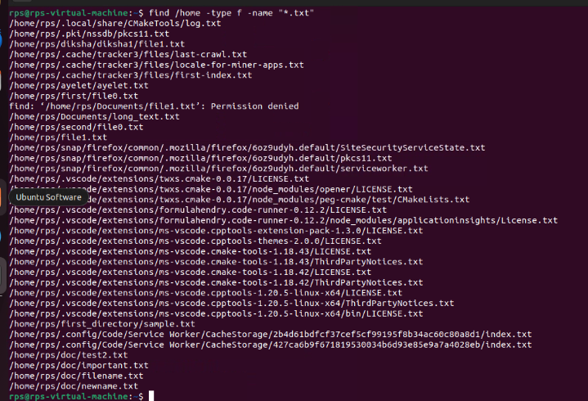

File Permissions:

Write a command to change the permissions of all files in the /var/log directory to 644.

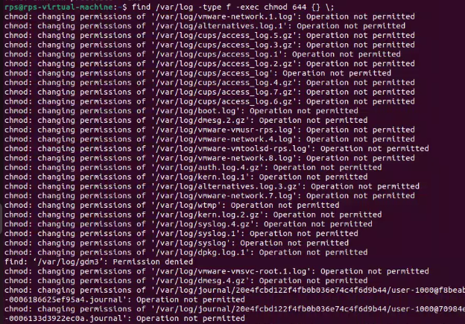

Disk Usage:

Write a command to display the disk usage of all directories in the /home directory in a human-readable format.

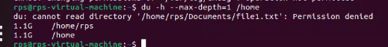

Process Management:

Write a command to list all running processes that contain the name "apache" in their command line.



Text Processing:

Write a command to count the number of lines in a file named error.log.



Network Configuration:

Write a command to display the IP address of all network interfaces on the system.

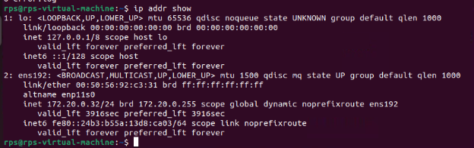

Package Management:

Write a command to install a package named htop using the package manager.

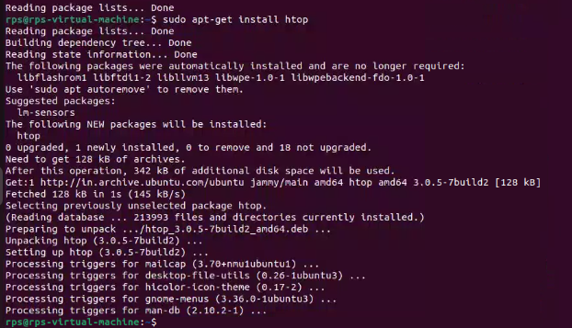

User Management:

Write a command to add a new user named developer to the system.



File Compression:

Write a command to compress a directory named backup into a .tar.gz file.

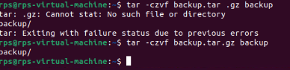

System Monitoring:

Write a command to display real-time system resource usage, including CPU, memory, and disk I/O.

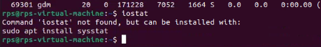

Shell Scripts

Backup Script:

Write a shell script to back up a directory named /data to /backup with the current date appended to the backup file name.

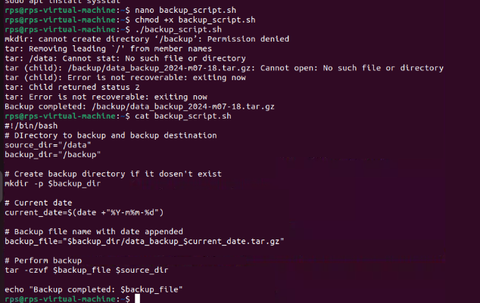

Log Rotation:

Write a shell script to rotate log files in the /var/log directory, keeping only the last 7 days of logs.

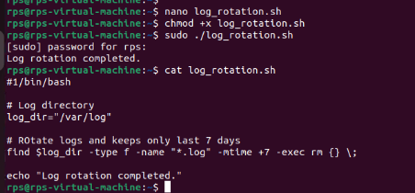

User Report:

Write a shell script to generate a report of all users currently logged into the system and save it to a file named user_report.txt.

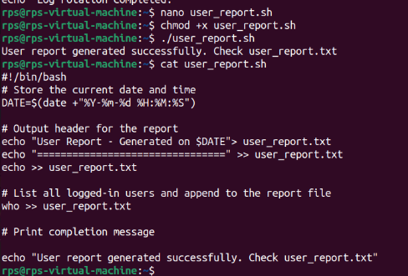

Disk Space Alert:

Write a shell script to check the disk usage of the /home directory and send an email alert if the usage exceeds 80%.

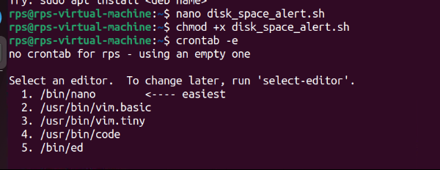

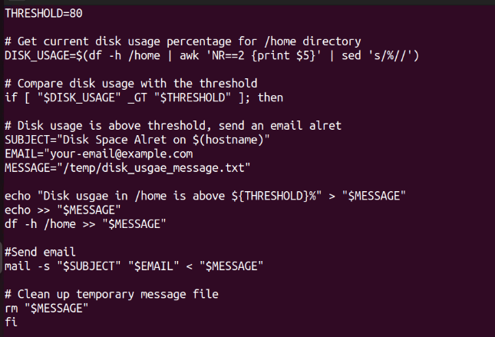

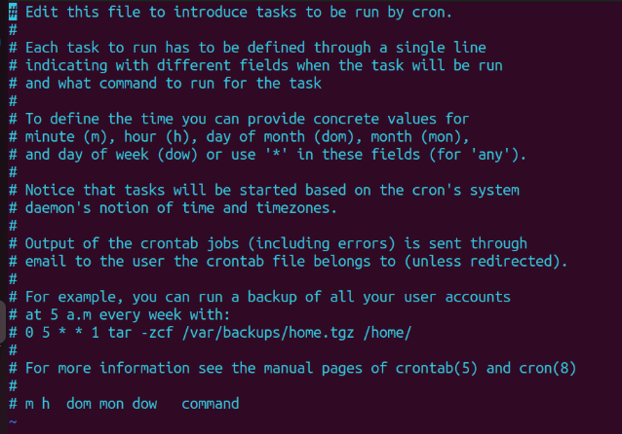

Service Monitor:

Write a shell script to check if the nginx service is running and restart it if it is not.

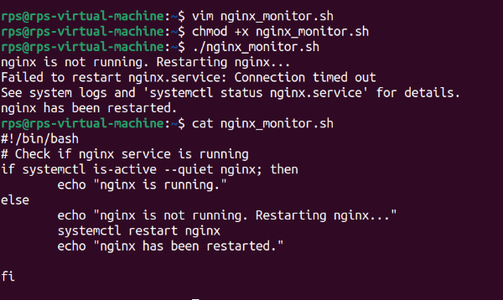

File Cleanup:

Write a shell script to delete all files older than 30 days in the /tmp directory.

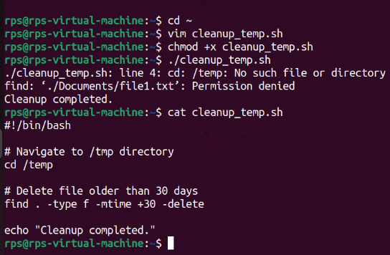

Automated Updates:

Write a shell script to automatically update all installed packages on the system.

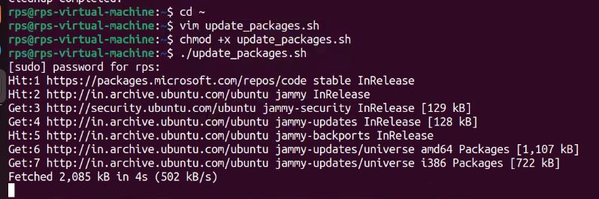

Database Backup:

Write a shell script to back up a MySQL database named sales to a file named sales_backup.sql.

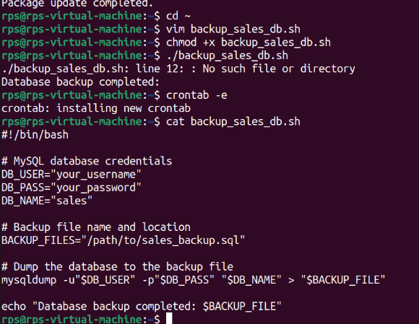

System Information:

Write a shell script to display system information, including hostname, OS version, and kernel version.

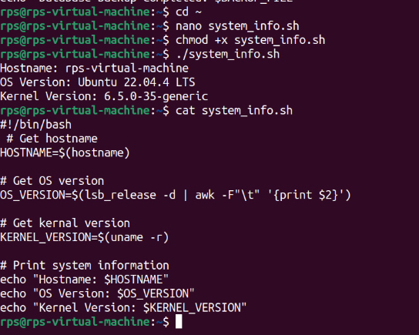

Cron Job:

Write a shell script to schedule a cron job that runs a specific command every day at midnight.

